Friends of Chelmsford Museums visit to Warner Textile Archive
& Braintree Museum on Tuesday16th June 2026
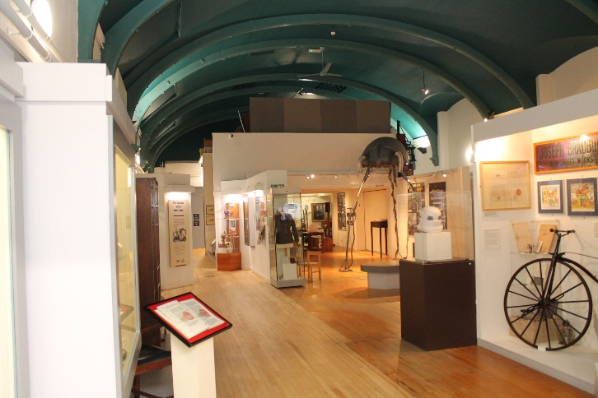

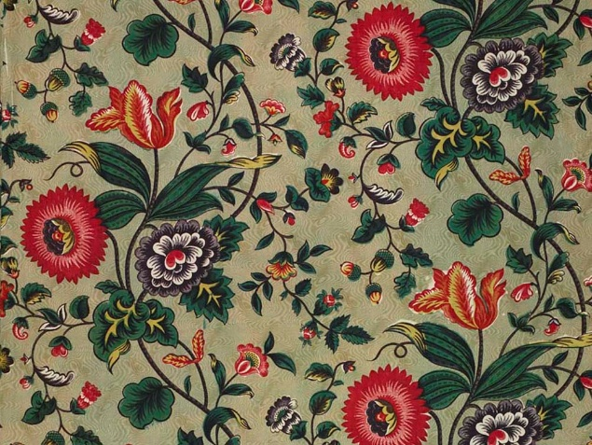
Our visit in June this year will be to the Braintree Museum in the morning starting at 10.30am where we will be given an introductory talk on the Warner Textile Archive. This will be followed by light refreshments and an opportunity to look around the Museum which includes the current exhibition on Art Deco. Following this the group will walk down to the Warner Textile Archive where they will be conducted on a themed tour of the Archive. Details with regard to parking etc. will be sent nearer to the visit.

The cost of this event will be Members £15.00 and non-Members £17.00. Please return the form below with a cheque made payable to The Friends of Chelmsford Museums to Christine Hall, Braemar, The Green, Hatfield Peverel, Chelmsford, CM3 2JQ (tel. 01245 382133, email christinehall@outlook.com). Alternatively, payment may be made by credit transfer to Metro Bank, sort code: 23-05-80 account: The Friends of Chelmsford Museums, a/c no. 43165984. Whichever payment method is used, the booking form below should be completed and sent to Christine Hall.
This event is subject to The Friends’ Events Booking Terms and Conditions, (copy available).

Cut here and send, retaining upper portion for details………………………………….

Friends of Chelmsford Museums visit to Braintree Museum & Warner Archive 16 June 26
No. attending: Members Non-members
I enclose a cheque for OR payment made by credit transfer for
Names
Telephone Number
E mail address
Address
I need a lift I can offer a lift Please state number

