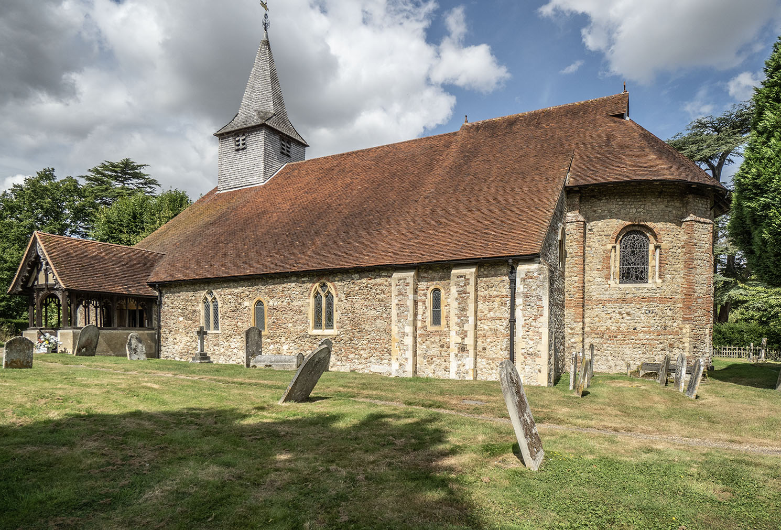
Friends of Chelmsford Museums visit to Copford Church 11th May 2026

Photo: Robert Hall

Our visit to the Church of St. Michael and All Saints, Copford begins at 10.30 a.m. I will issue directions to this pretty woodland site to those attending. We will be given a guided tour of the church, starting outside if the weather allows covering the history of the area, other buildings, farming practices and the people throughout history who have left their mark for good or otherwise. We will see the famous wall paintings made shortly after the completion of the church in 1130A.D.
“Rather naughty home-made cakes” are included as are savouries (gluten-free if requested) and tea, coffee and cold drinks. There is car-parking and one lavatory in the church. There is disabled access to the church but access to the churchyard, including the burial place of Essex artist Eric Ravilious, is not on paths and appropriate footwear is recommended. The cost is £10.00 per member (£12.00 per non-member). Please return the below form to David Jones, 93, Hillside Grove, Chelmsford. CM2 9DB (Tel:01245 281899 david_jones@btinternet.com) enclosing a cheque made payable to The Friends of Chelmsford Museums or payment may be made by credit transfer to Metro Bank, sort code 23-05-80, account: The Friends of Chelmsford Museums, a/c no. 43165984. Whichever payment method is used, please ensure the form is sent to David Jones either by post or e mail. Event subject to The Friends’ Events Booking Terms and Conditions (copy available or see our website)

Cut here and send, retaining upper portion for details………………………………….

Friends of Chelmsford Museums visit to Copford Church 11th May 2026
No. attending: Members Non-members
I enclose a cheque for OR payment made by credit transfer for
Names
Telephone Number
E mail address
Address
I need a lift I can offer a lift Please state number

